**FSAD WEEK 2:**

**CREATE TABLE:**

CREATE TABLE student; (

student_id INT PRIMARY KEY,

student_name VARCHAR(100) NOT NULL,

email VARCHAR(100),

age INT,

gender CHAR(1),

city VARCHAR(50),

admission_date DATE,

mentor_id INT

);

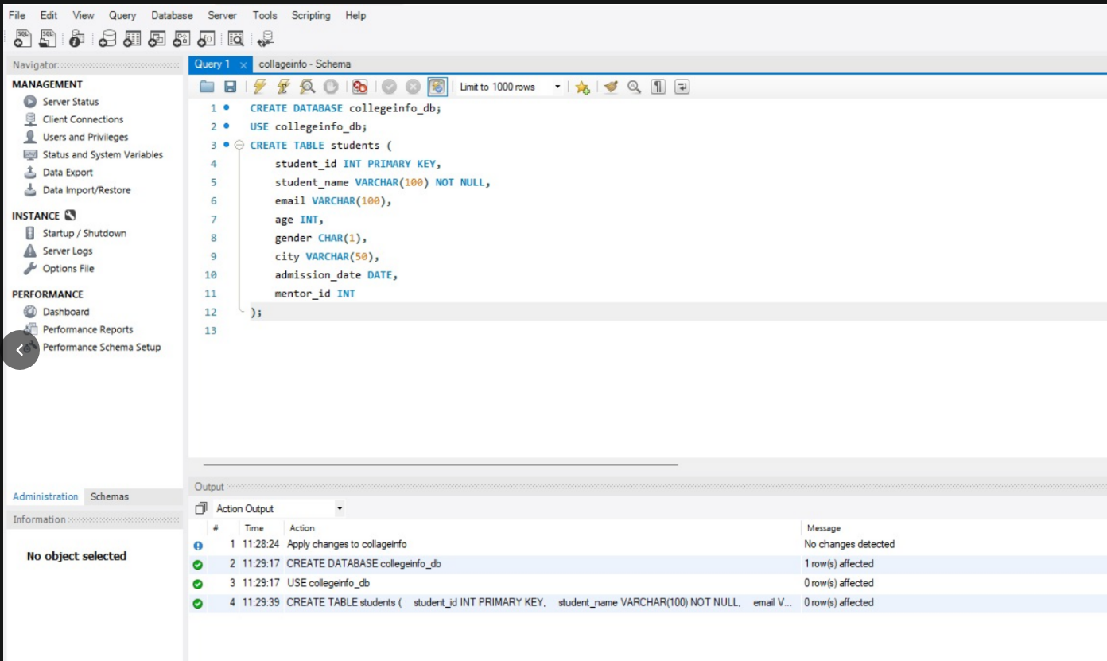

**INSERT:**

**INSERT INTO students VALUES**

**(1, 'Aarav', 'aarav@gmail.com', 20, 'M', 'Delhi','2022-06-10', NULL),**

**(2, 'Neha','neha@gmail.com',21, 'F', 'Mumbai', '2021-07-15', 1),**

**(3, 'Rahul', NULL, 22, 'M', 'Delhi','2022-01-12', 1),**

**(4, 'Priya', 'priya@gmail.com', 20, 'F', NULL, '2023-03-20', 2),**

**(5, 'Karan', 'karan@gmail.com', 23, 'M', 'Pune','2021-11-01', 2),**

**(6, 'Anita', NULL, 21, 'F', 'Mumbai', '2022-08-05', 3);**

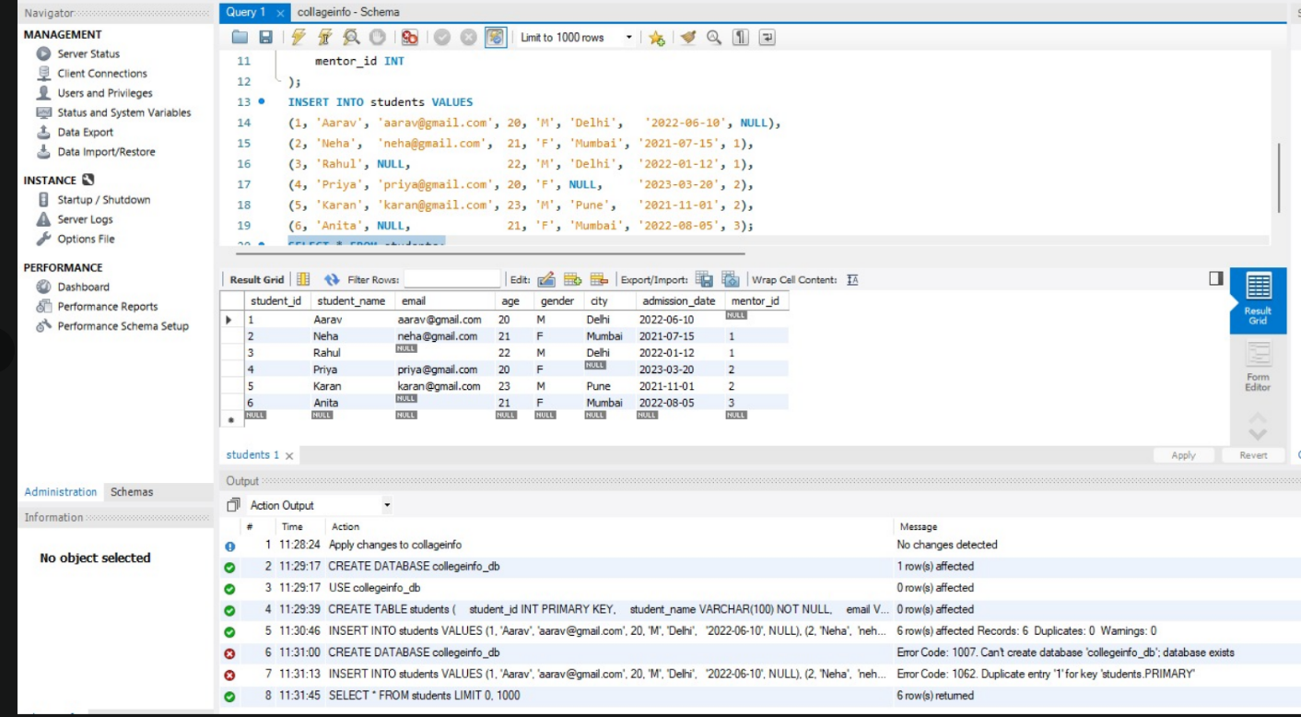

SELECT:

SELECT

student_id,

student_name,

(SELECT COUNT(*) FROM students) AS total_students

FROM students;

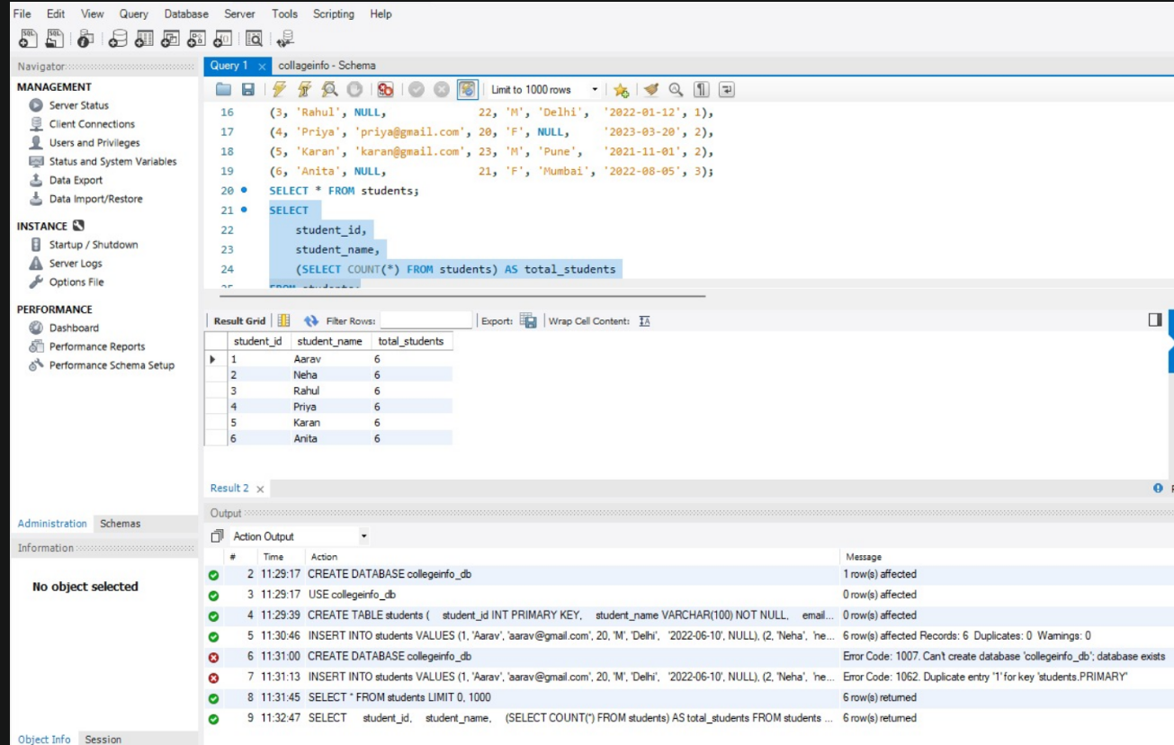

WHERE:

**SELECT \***

**FROM students**

**WHERE age > (**

**SELECT AVG(age)**

**FROM students**

**);**

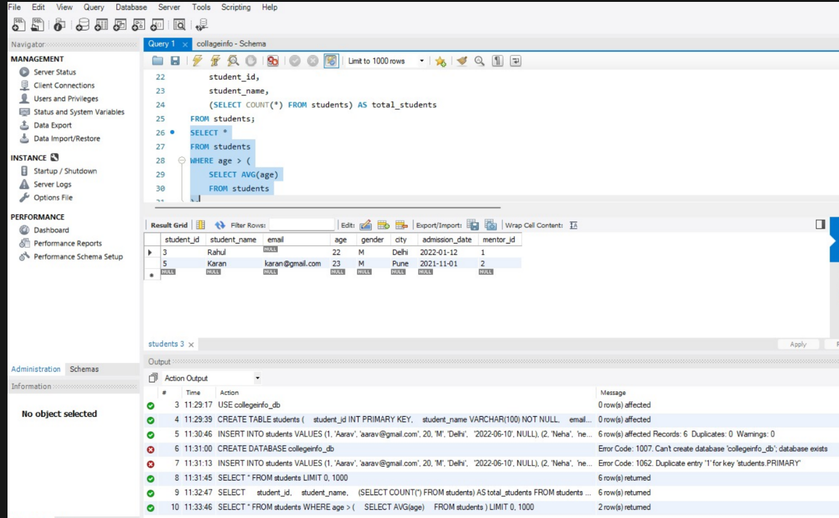

INSERT SUBQUERY:

CREATE TABLE senior_students (

student_id INT,

student_name VARCHAR(100),

age INT

);

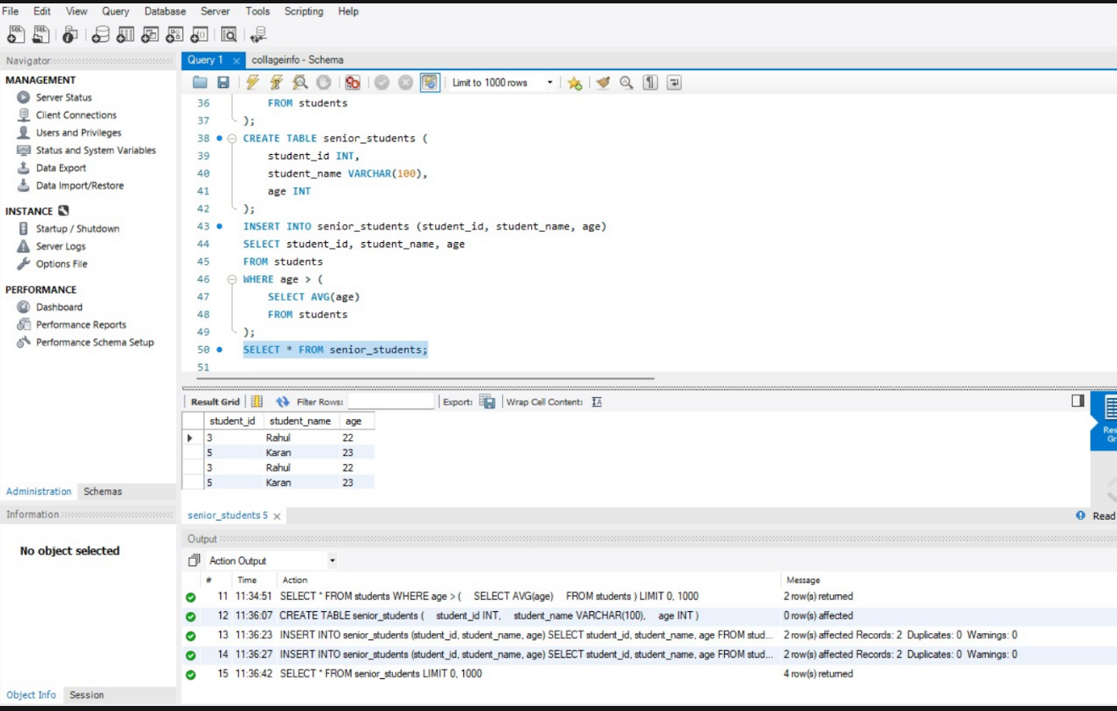

CURRENT DATE AND CURRENT TIME

INSERT INTO senior_students (student_id, student_name, age)

SELECT student_id, student_name, age

FROM students

WHERE age > (

SELECT AVG(age)

FROM students

);

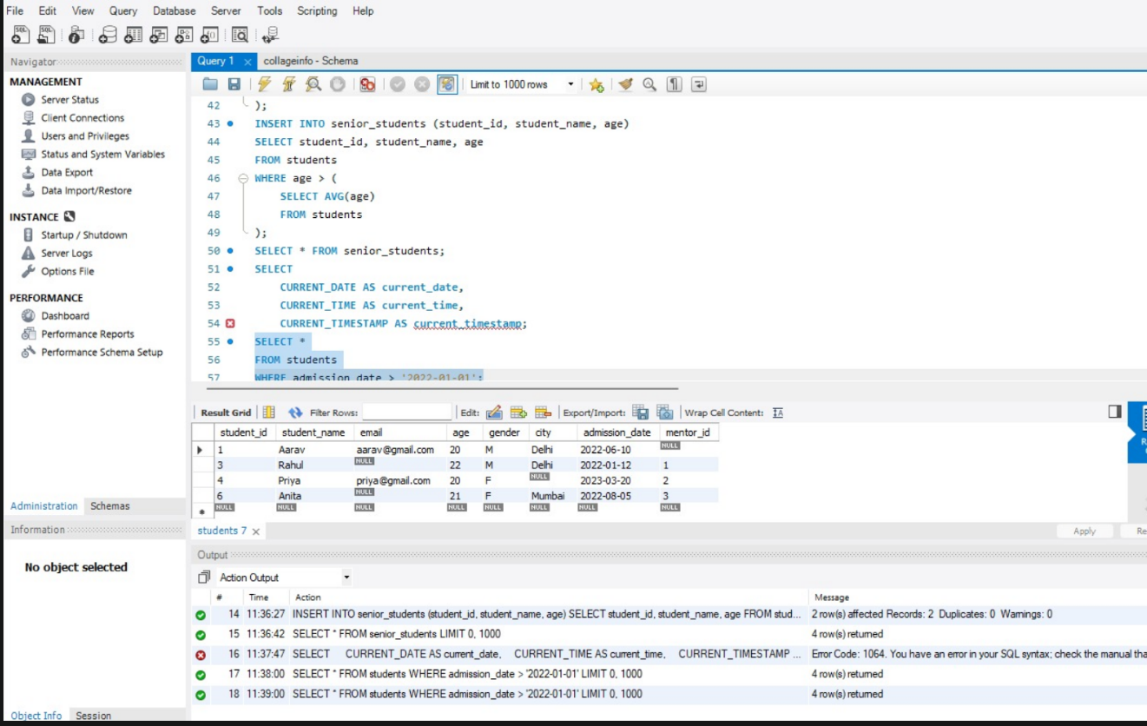

CURRENT TIME STAMP

